OBJECTIVE
Introduction to Eclipse IDE, creating projects, its classes and mapping UML class diagram in to java code.
Lab Task:
Write the java code with the help of the given class diagram of Hospital Management System.
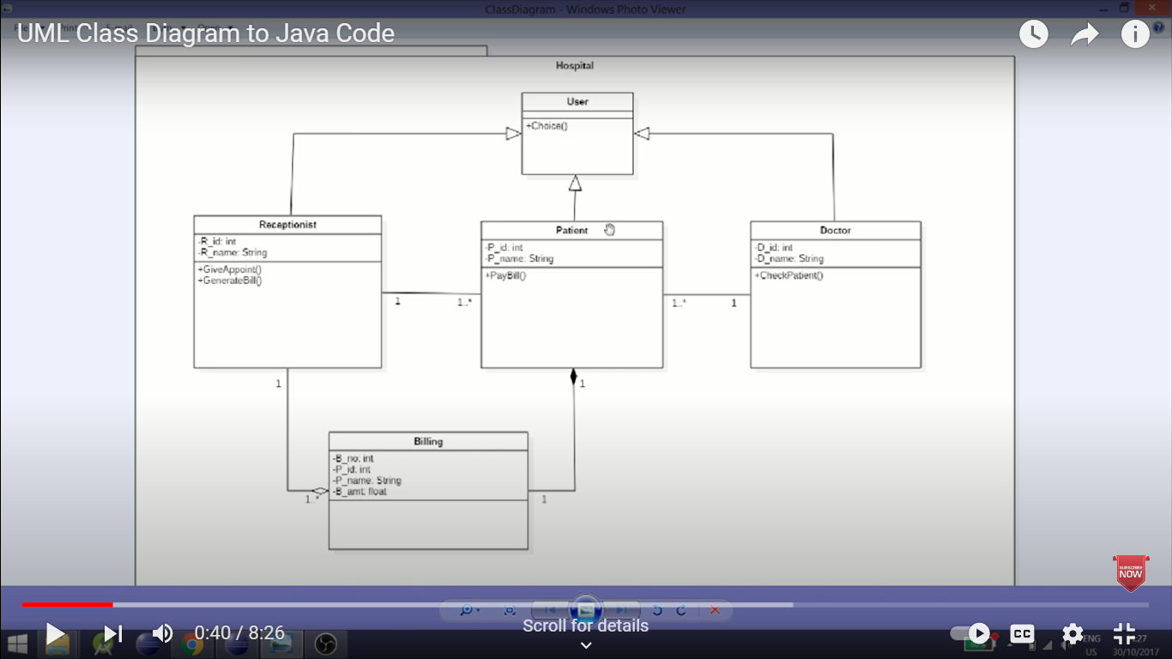

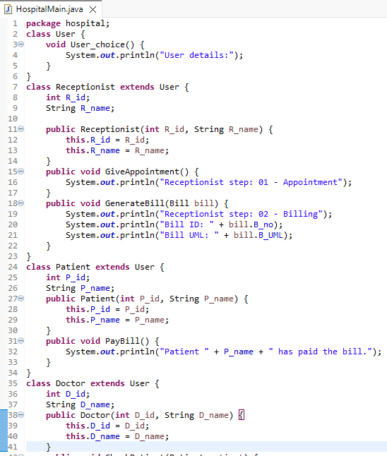
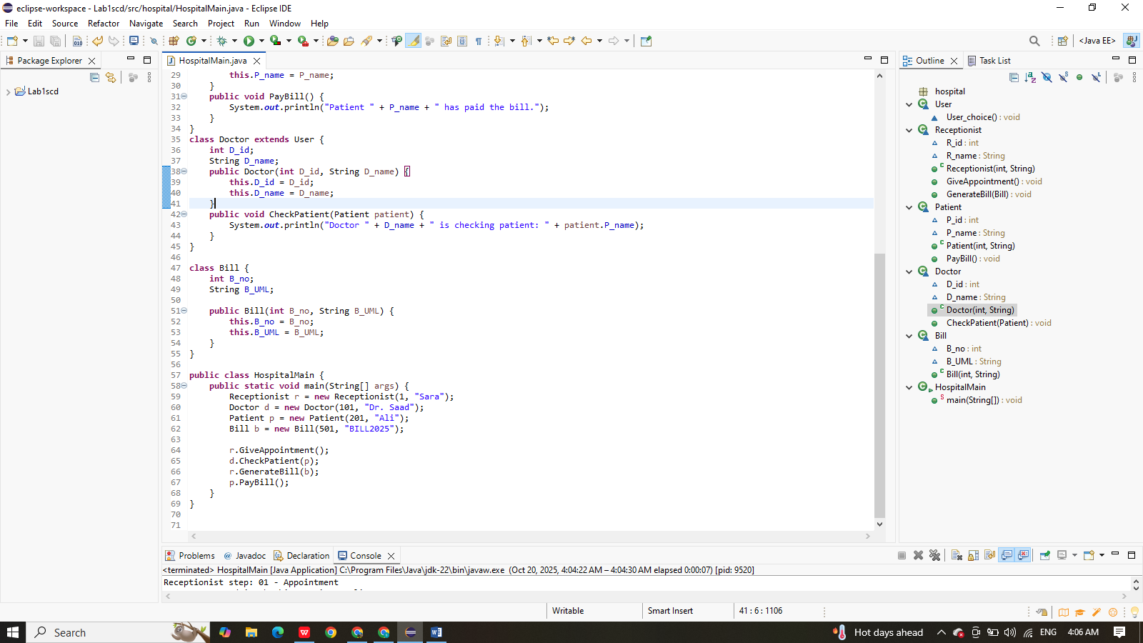
OUTPUT:
